PROJECT REPORT

ON

HOTEL MANAGEMENT SYSTEM

Quest Global Trainees

*Submitted by*

ASHLIN V RAJAN

P JATHIN JOHNY

NIBIMOL ABRAHAM

RUBIN SABU

*Under the Guidance of*

MR. PREM RAJ

INDEX

1. Introduction…………………………………………………………………………….03

    1.1 Purpose…………………………………………………………………………….03

    1.2 Motivation…………………………………………………………………………03

2. Literature survey……………………………………………………………………….04

3. Requirements.…………………………………………………………………………05

    3.1 Functional Requirements………………………………………………………….05

    3.2 Hardware Requirements…………………………………………………………...05

    3.3 Software Requirements……………………………………………………………05

3.4 Waterfall Model……………………………………………………………………06

4. System Architecture…………………………………………………………………...07

    4.1 ONE-Tier Architecture……………………………………………………………08

5. Design and Implementation…………………………………………………………...09

    5.1 Product Features…………………………………………………………………...09

5.2 Database table and design…………………………………………………………10

    5.3 Class diagram design………………………………………………………………11

    5.4 Use case diagram………………………………………………………………….12

    5.5 Sequence diagram…………………………………………………………………13

6. Snapshots……………………………………………………………………………...13

7. Conclusion……………………………………………………………………………..18

8. Bibliography…………………………………………………………………………...19

1. INTRODUCTION

The project, Hotel Management System is a web-based application that allows the hotel manager to handle all hotel activities online. Interactive GUI and the ability to manage various hotel bookings and rooms make this system very flexible and convenient. The hotel manager does not have the time to sit and manage the entire activities manually on paper. This application gives him the power and flexibility to manage the entire system from a single online system. The hotel management project provides room booking, staff management and other necessary hotel management features. Customers can view and book rooms online. Admin has the power to add/delete staff and view/delete customer details. Other hotel services can also be viewed by the customers. The system is hence useful for both Admin and Staff to portable manage the hotel activities.

1.1 Purpose

The purpose of this document is to build an online hotel management system website named **SALT&PEPPER** for a company whose customers can book rooms, admin can manage staff details and the admin/staff can handle customers’ data.

1.2 Motivation

Hotel management software is a technology that allows hotel operators and owners to streamline their administrative tasks while also increasing their bookings in both the short and long term. In this modern era of globalization, most travellers use hotels as a means of accommodation and tourism.

2. LITERATURE SURVEY

* Nowadays, numerous individuals and organizations are grasping the hotel management system. Because of the wild rivalry in online hotel booking, associations inside this segment are creating systems that will enhance their services to customers and hotel managers.
* Part of the reason why hotels utilize technological systems in their operations is because it keeps them up to date in terms of where they are placed in the market. It makes work easier for staff members, allowing them to work more efficiently and taking away time consuming activities which can be carried out by the technology. In some hotels, the utilization of technological systems mean that fewer staff members are needed and this saves considerable costs. For others, especially luxury hotels, this is not the case but it means that the staff can be free to attend to customers on a more personal basis, thus upholding high standards. Therefore, it is understandable that 5 star hotels must ensure that they employ the most advanced technology available. This is because their priority is maintaining their position and status as a luxury brand, rather than cutting costs, which would be more of a priority for budget hotels which cater to a lower end market. Therefore luxury tourist establishments rely on top-quality technological systems.
* The main use of information technology will be in enhancing customer service, rather than replacing it. For example, many hotels use technological booking systems which make it easy for clients to book online and to have all the information they need about the rooms available to them. They also use technology within the hotel to benefit the customer during their stay. For example, many have advanced communications systems installed in the rooms which means that those on business trips can continue with their work while they are guests at the hotel. Once again, in 5-star hotels, it is all the more important to provide these facilities; customers pay a lot of money and so expect to have a certain amount of facilities and quality additions provided for them.

3. REQUIREMENTS

3.1 Functional Requirements

* Every online booking needs to be associated with an account
* One account cannot be associated with multiple users
* Search results should enable users to find the aptest and relevant booking options
* System should only allow users to move to booking only when mandatory fields such as Phone number, Address, Room type, Arrival date, and other details have been mentioned.

3.2 Hardware Requirements

* RAM: 8 GB
* Hard Disk: 1TB
* Processor: Intel(R) Core (TM) i5-8265U CPU @ 1.60GHz, 1800 MHz, 4 Core(s), 8 Logical Processor(s)

3.3 Software Requirements

* JSP
* Servlets
* Java 1.8
* TomCat Server
* Oracle database
* HTML
* CSS
* Eclipse IDE
* Google Chrome

3.4 Waterfall Model

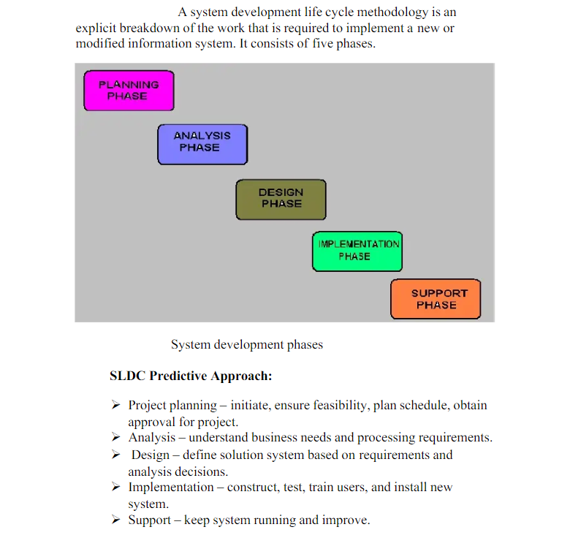

4. SYSTEM ARCHITECTURE

The computer-based reservation application utilizes client/server engineering. At the client by utilizing Windows gadget can interface by means of the internet with a java servlet that JSP and Oracle Database in server side in charge of the clients' solicitations procedures and spare or return information from the database. fig 1 speaks to review of proposed reservation system outline.

Oracle

Database

Java

Servlet

JSP

Internet

Web

Browsing

Fig 1: - System Overview Design

4.1 ONE-Tier Architecture



Inside One System

5. DESIGN AND IMPLEMENTATION

5.1 Product Features

1. **Room Booking: -** In this module, the customer can register themselves by giving some details like their name, phone number, email, address, arrival date, room type, and no. of days.
2. **Staff login: -** In this module, the Staff can login by giving their login id (that was provided by the hotel to them) and password that they have generated.
3. **Admin login: -** In this module, the Admin can login by giving this/her login and password that they have generated.

*After this the Booking of ticket is done.*

1. **Admin account: -** In this module, Admin can choose to view Customer/Staff details.
2. **Add/View/Delete Staff: -** In the Admin account after selecting ‘Staff’, the admin can view all staff member details, add more staff members and their details, and remove staff members already present.
3. **View/Delete Customers: -** In the Admin account after selecting ‘customer’, the admin can view all customers’ details and remove customers if required.

1. **View Customer History: -** In this module, if the admin wants to know the previous customers’ details, then he/she can get details of a particular customer by customer phone number.

5.2 Database Table Design

We have used Oracle 11g Express Edition Database.

1. Booking Table (made for the customers who books room)

SQL> desc booking;

|  |  |  |
| --- | --- | --- |
| Name | Null? | Type |
| ROOM_NUMBER | NOT NULL | NUMBER(10) |
| CUS_NAME |  | VARCHAR2(40) |
| EMAIL |  | VARCHAR2(50) |
| PHONE_NUMBER |  | VARCHAR2(15) |
| ROOM_TYPE | NOT NULL | VARCHAR2(30) |
| DATE_ARRIVAL |  | VARCHAR2(20) |
| NUMBER_OF_PERSONS |  | NUMBER(10) |
| NUMBER_OF_DAYS |  | NUMBER(10) |
| ADDRESS |  | VARCHAR2(60) |

2. Employee Details Table

SQL> desc employeedetails;

|  |  |  |
| --- | --- | --- |
| Name | Null? | Type |
| EMPLOYEEID | NOT NULL | NUMBER(10) |
| EMPLOYEENAME | NOT NULL | VARCHAR2(25) |
| PASSWORD | NOT NULL | VARCHAR2(20) |
| EMPTYPE | NOT NULL | VARCHAR2(20) |
| SALARY | NOT NULL | NUMBER(10) |

3. Customer Details history Table (for storing the previous customer details)

SQL> desc history;

|  |  |  |
| --- | --- | --- |
| Name | Null? | Type |
| ROOM_NUMBER |  | NUMBER(10) |
| CUS_NAME |  | VARCHAR2(40) |
| EMAIL |  | VARCHAR2(50) |
| PHONE_NUMBER |  | VARCHAR2(15) |
| ROOM_TYPE |  | VARCHAR2(30) |
| DATE_ARRIVAL |  | VARCHAR2(20) |
| NUMBER_OF_PERSONS |  | NUMBER(10) |
| NUMBER_OF_DAYS |  | NUMBER(10) |
| ADDRESS |  | VARCHAR2(60) |

5.3 Class diagram design

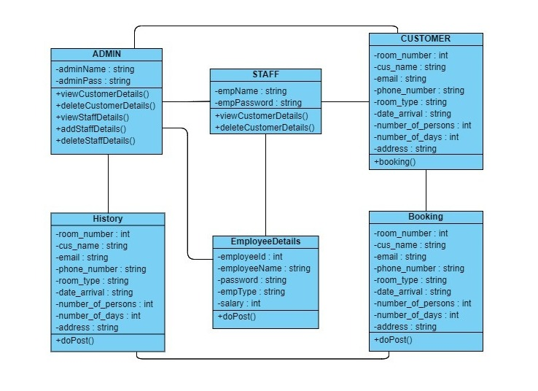

5.4 Use case diagram

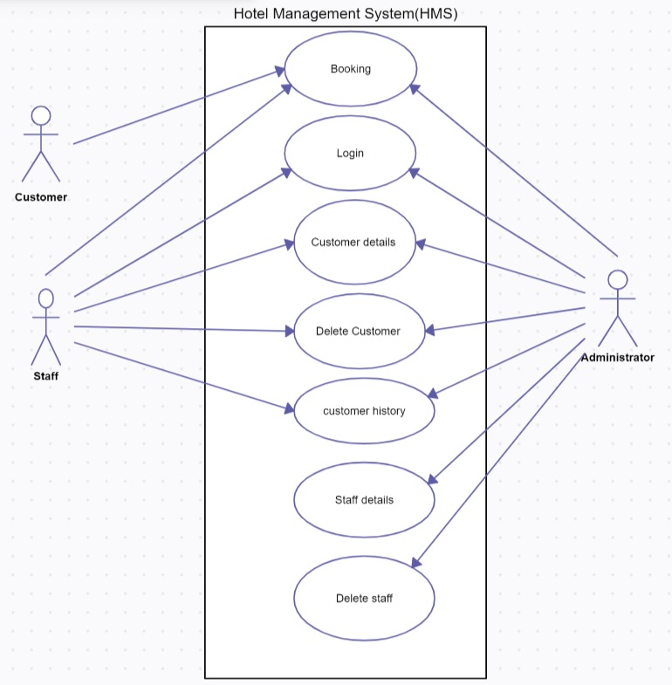

5.5 Sequence diagram

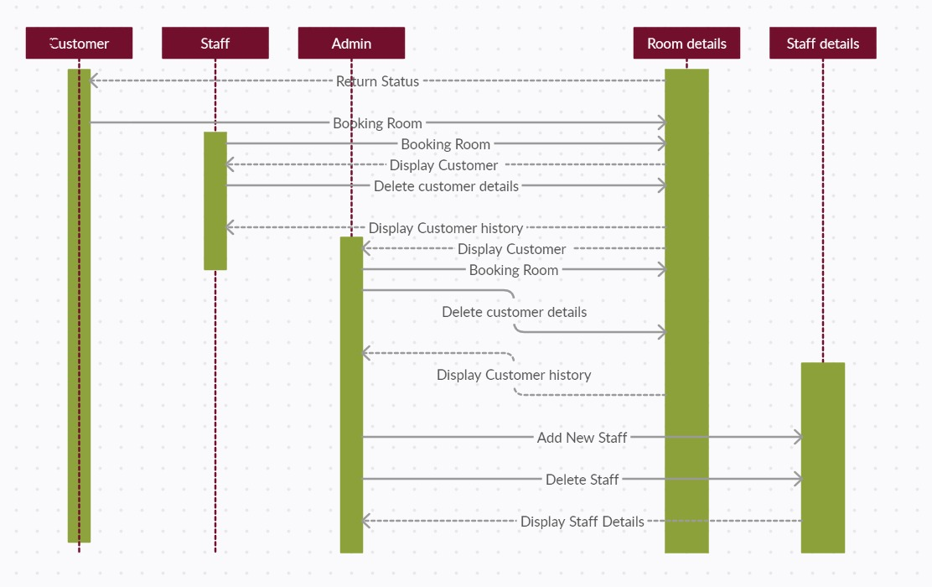

6. SNAPSHOTS

1. Home Page

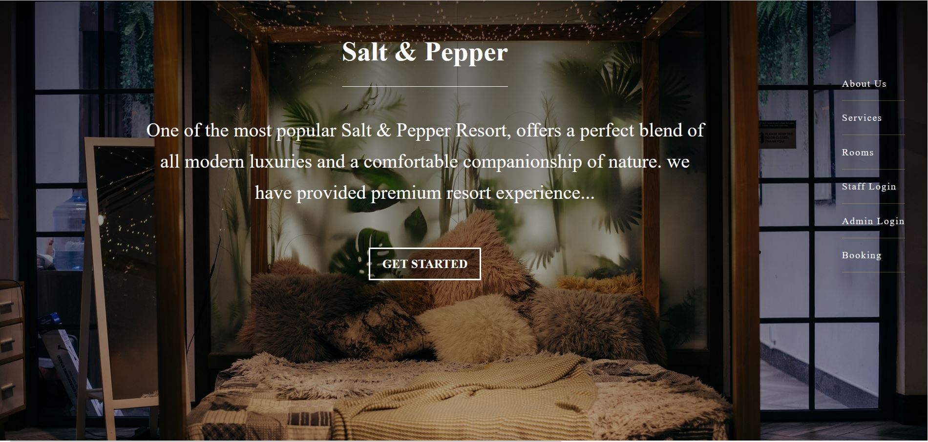

2. Hotel Rooms

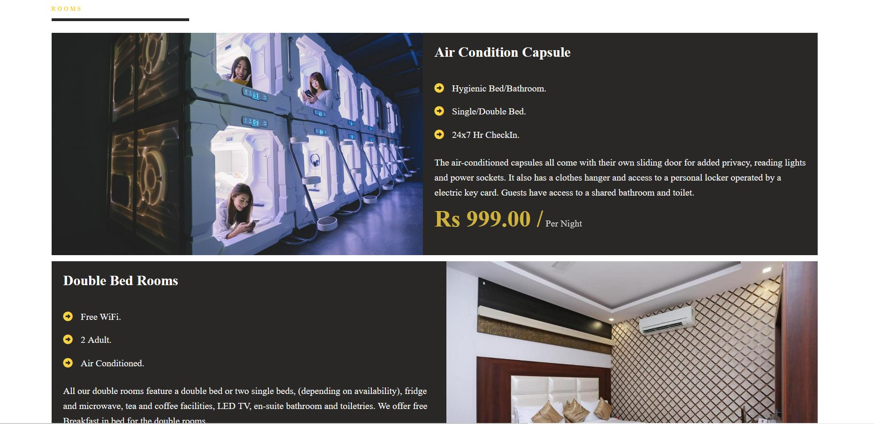

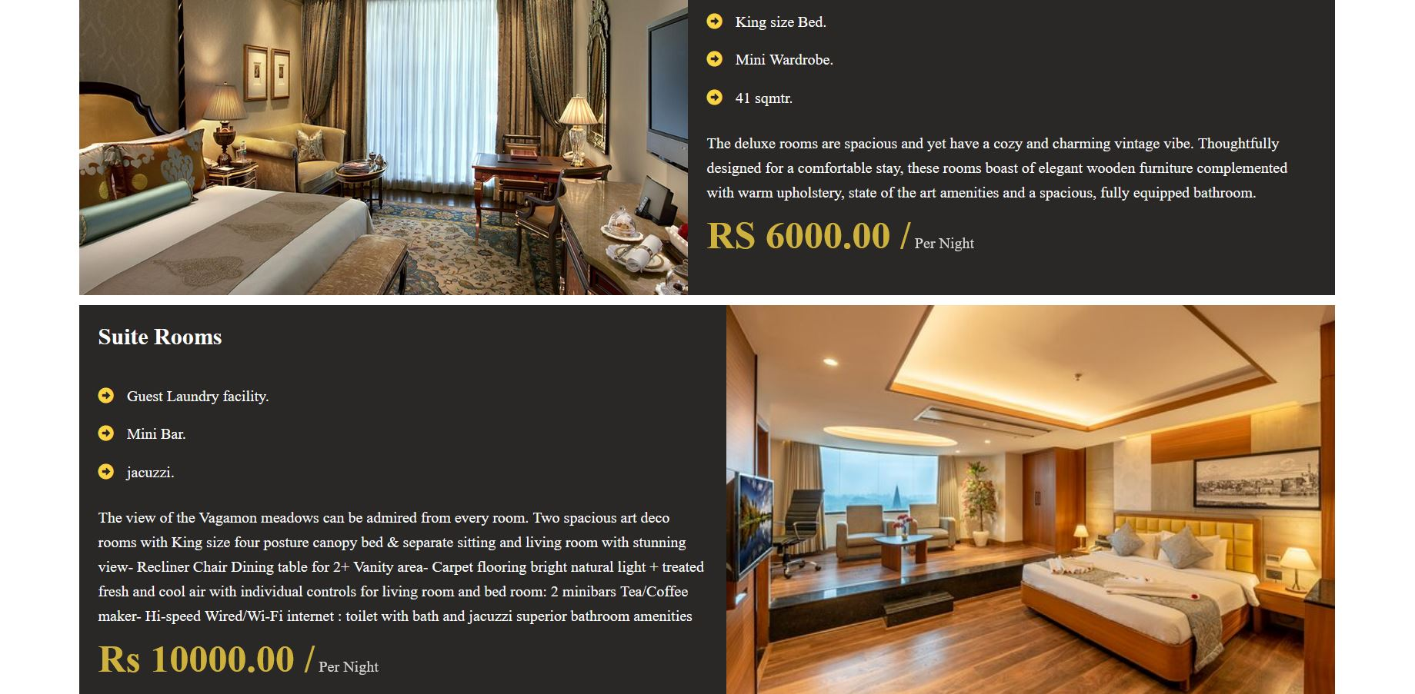

3.Room Booking Page

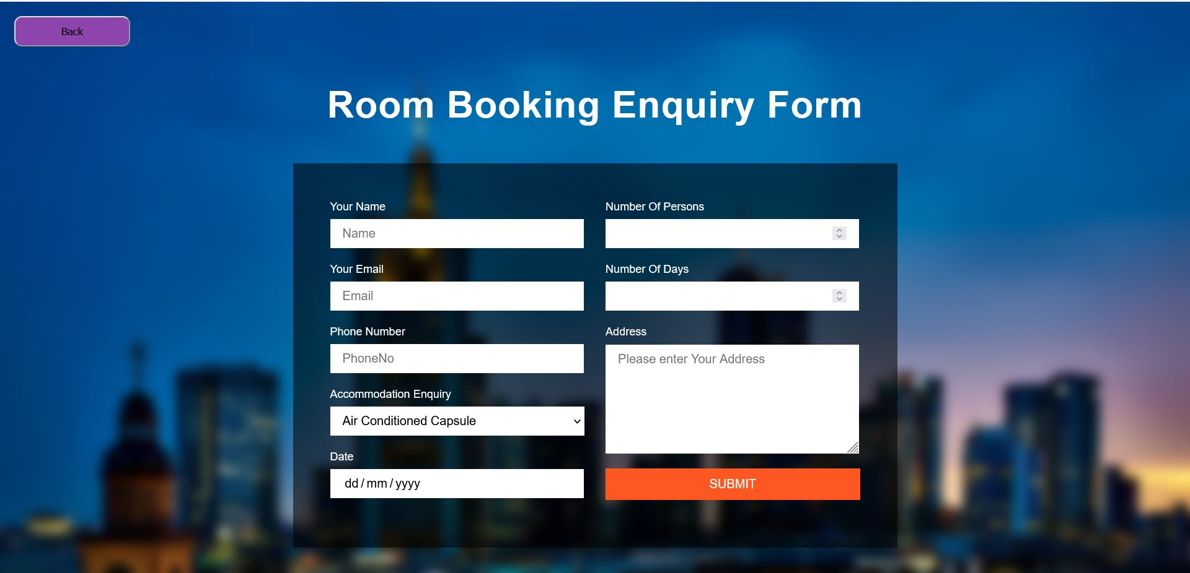

4. Admin/Staff Login Page

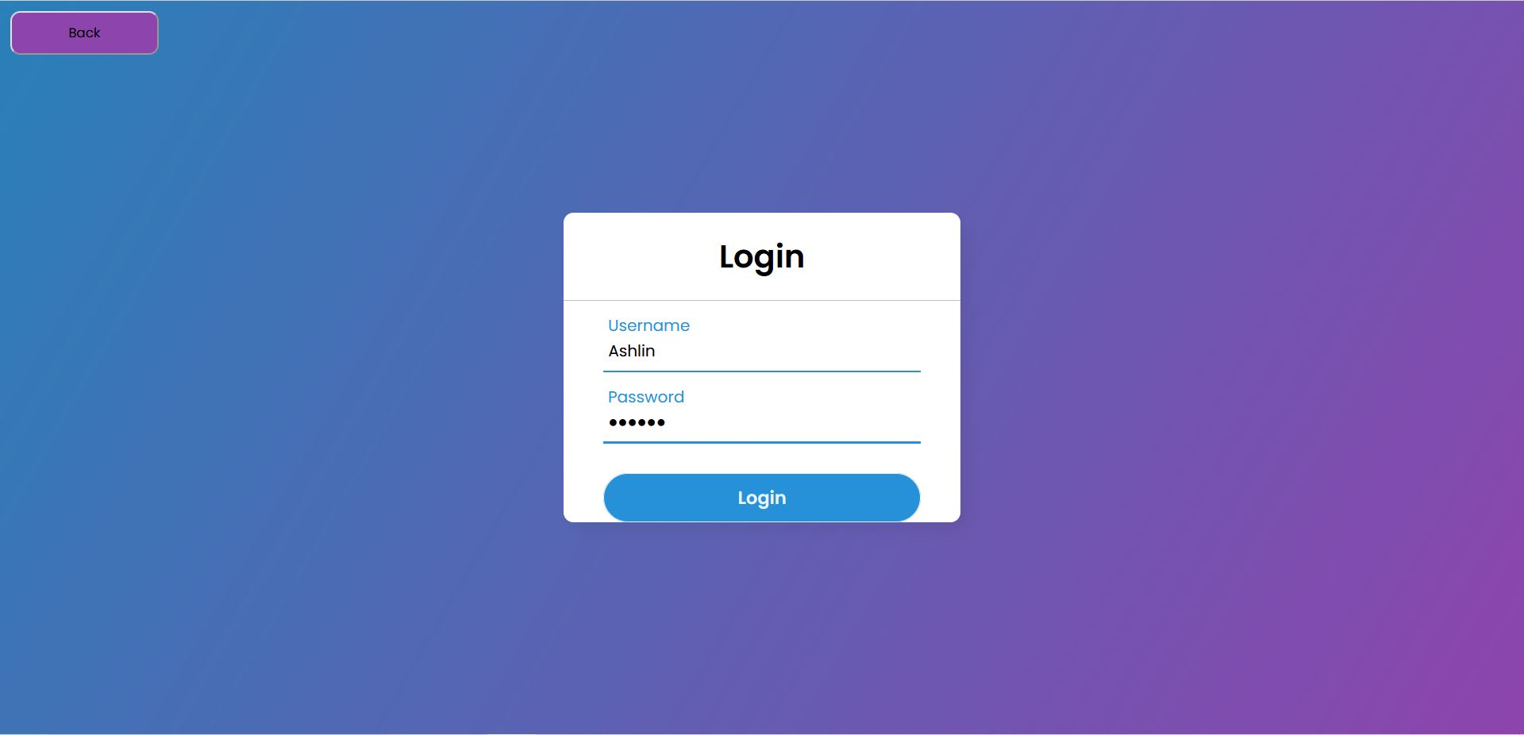

5. Customer Details Page

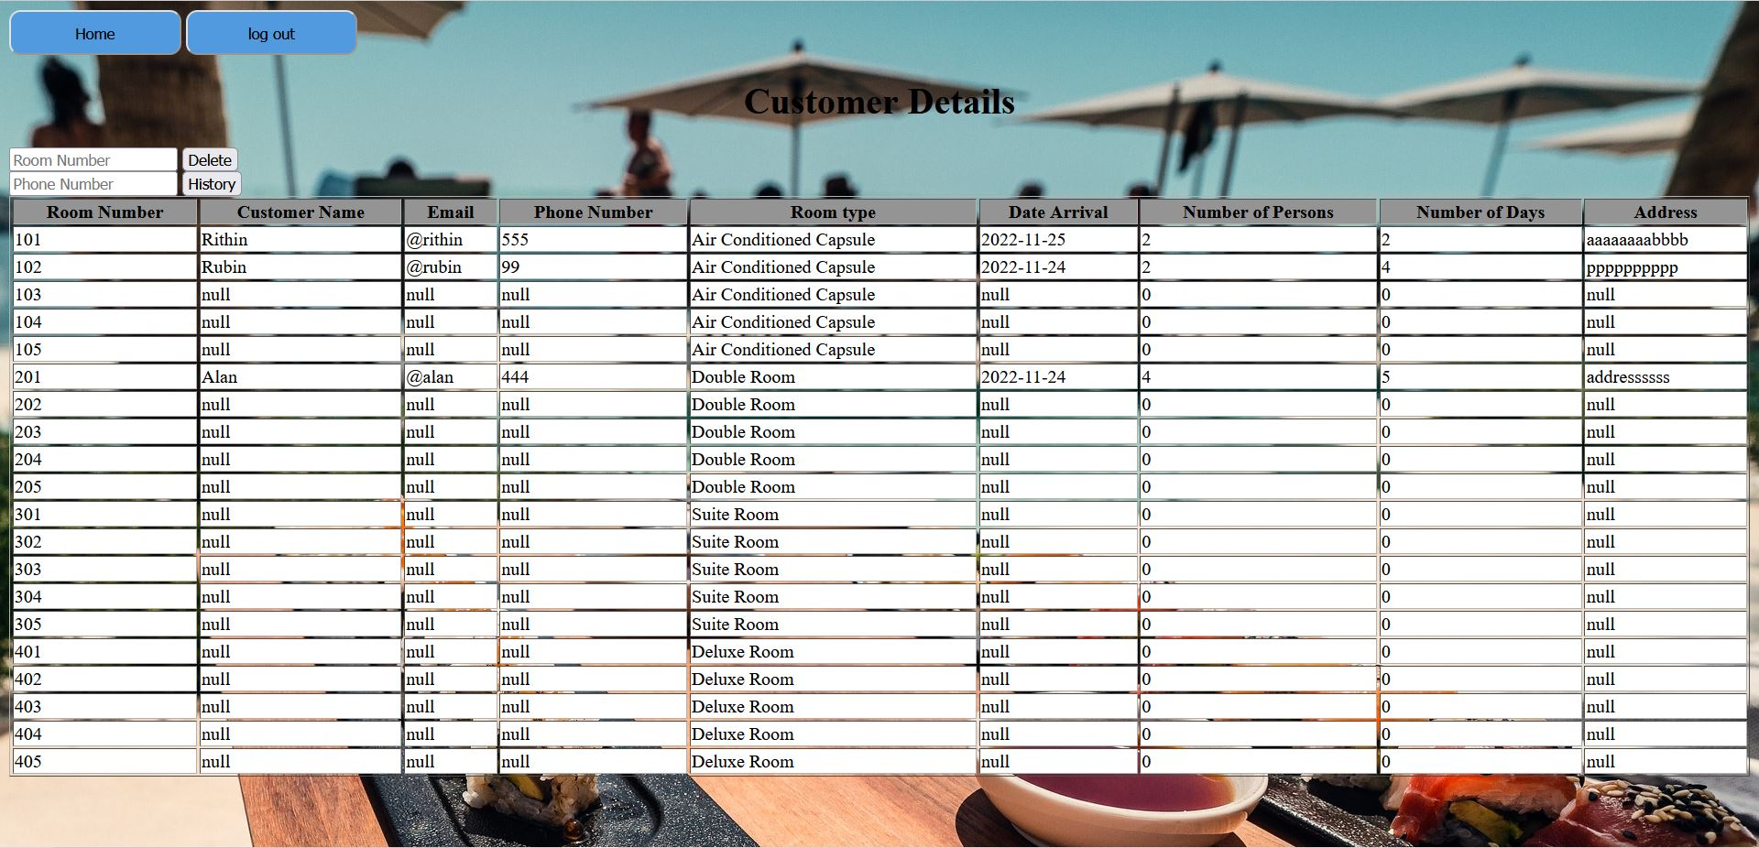

6. Admin Page

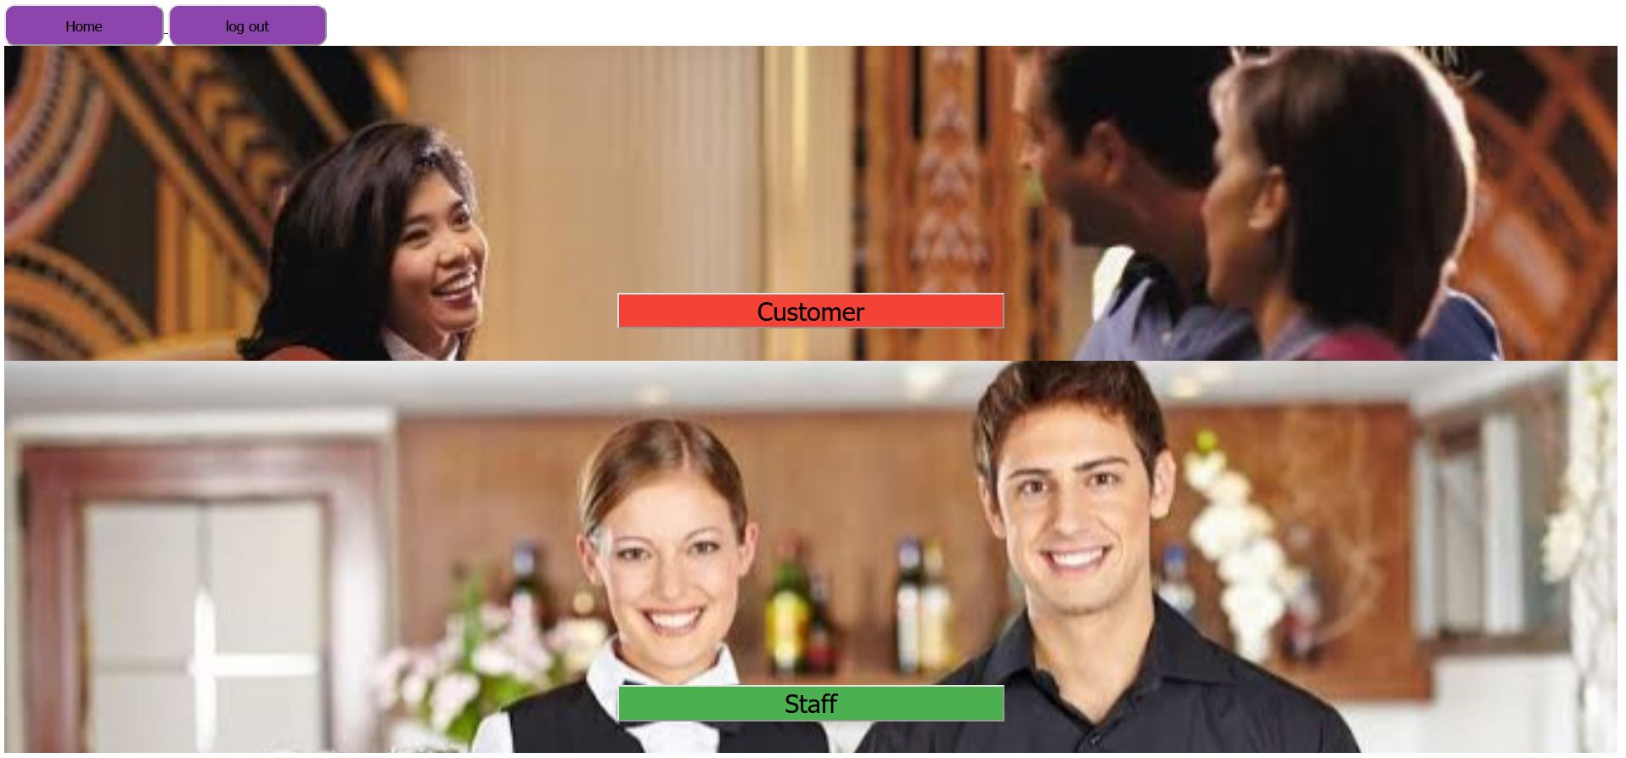

7. Staff Details Page

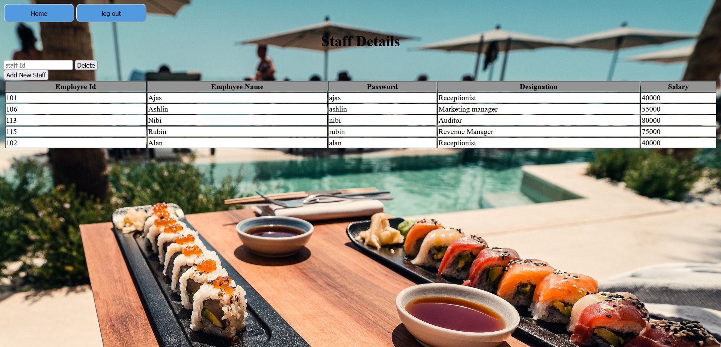

8. Add Staff Page

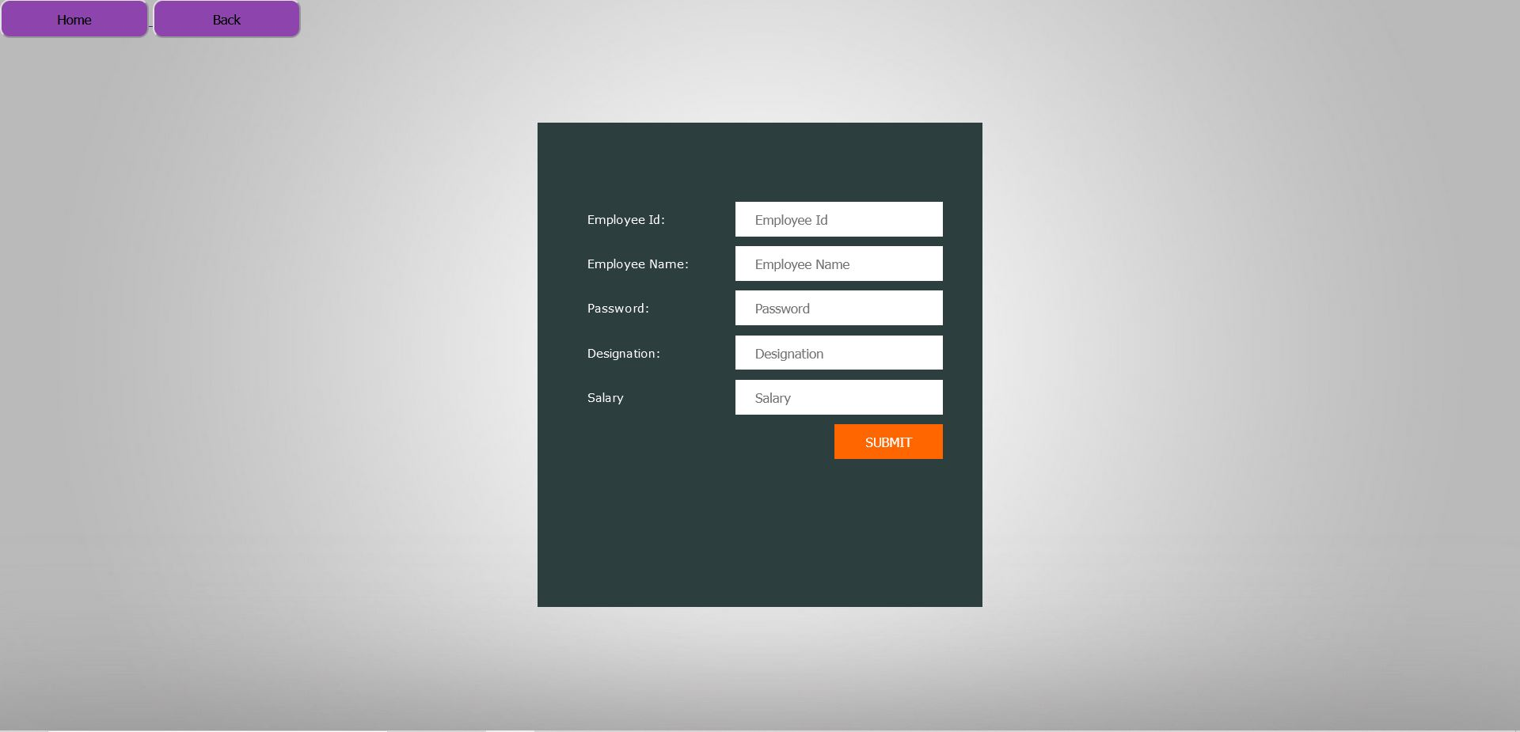

7. CONCLUSION

Hotel management systems now-a-day have the advantage of modernization. Computers have done the work more easily. Reports are made on daily basis for every customer check-in or check out which can easily be seen by the management. The hotel management system’s primary purpose is to provide facilities to customers, administrator, and staff. A website for hotel management makes things many times easy, these are made as user friendly and keep a check and balance in hotel management.

8. BIBLIOGRAPHY

Some of the references used for preparing the vision document include:

• <https://tomcat.apache.org/tomcat-7.0-doc/servletapi/index.html>

* <https://docs.oracle.com/javase/8/docs/api/>

• S. Koolmanojwong, "Analysis and Design of B to C E-Marketplace for Tourism with UML", M.S. Thesis Faculty of Science and Technology, 2000.

• Pathak, A. Snghal and B. K. Rana, "Review on Hotel Management System," 2021 3rd International Conference on Advances in Computing, Communication Control and Networking (ICAC3N), 2021, pp. 1834-1837, doi: 10.1109/ICAC3N53548.2021.9725658.

• E-Draw software is used to generate the use case diagrams 15

* www.google.com